**2. Android Options Menu with Examples**

In android, **Options Menu** is a primary collection of menu items for an [activity](https://www.tutlane.com/tutorial/android/android-activity-lifecycle) and it is useful to implement actions that have a global impact on the app, such as Settings, Search, etc.

Following is the pictorial representation of using **Options Menu** in our android applications.

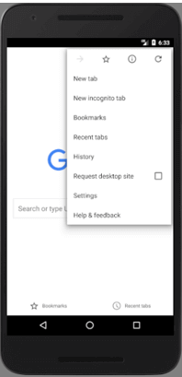

By using Options Menu, we can combine multiple actions and other options that are relevant to our current [activity](https://www.tutlane.com/tutorial/android/android-activity-lifecycle). We can define items for the options menu from either our [Activity](https://www.tutlane.com/tutorial/android/android-activity-lifecycle) or [Fragment](https://www.tutlane.com/tutorial/android/android-fragments-with-examples) class.

In case, if we define items for the options menu in both activity or fragment, then those items will be combine and display in UI.

**Create Android Options Menu in XML File**

In android, to define **options menu**, we need to create a new folder **menu** inside of our project resource directory (**res/menu/**) and add a new XML (**menu_example**) file to build the menu.

Following is the example of defining a menu in XML file (**menu_example.xml**).

|  |
| --- |
| <?xml version="1.0" encoding="utf-8"?> <menu xmlns:android="http://schemas.android.com/apk/res/android">     <item android:id="@+id/mail"         android:icon="@drawable/ic_mail"         android:title="@string/mail" />     <item android:id="@+id/upload"         android:icon="@drawable/ic_upload"         android:title="@string/upload"         android:showAsAction="ifRoom" />     <item android:id="@+id/share"         android:icon="@drawable/ic_share"         android:title="@string/share" /> </menu> |

**Load Android Options Menu from an Activity**

To specify the options menu for an activity, we need to override **onCreateOptionsMenu()** method and load the defined menu resource using **MenuInflater.inflate()** like as shown below.

|  |
| --- |
| @Override public void onCreateOptionsMenu(ContextMenu menu, View v, ContextMenuInfo menuInfo) {     super.onCreateContextMenu(menu, v, menuInfo);     MenuInflater inflater = getMenuInflater();     inflater.inflate(R.menu.menu_example, menu); } |

If we observe above code we are calling our menu using **MenuInflater.inflate()** method in the form of **R.menu.menu_file_name**. Here our xml file name is **menu_example.xml** so we used file name **menu_example**.

**Handle Android Options Menu Click Events**

In android, we can handle a options menu item click events using **onOptionsItemSelected()** event method.

Following is the example of handling a options menu item click event using **onOptionsItemSelected()**.

|  |
| --- |
| @Override public boolean onOptionsItemSelected(MenuItem item) {     switch (item.getItemId()) {         case R.id.mail:             // do something             return true;         case R.id.share:             // do something             return true;         default:             return super.onContextItemSelected(item);     } } |

**Android Options Menu Attributes**

Following are the some of commonly used attributes related to options menu control in android applications.

| **Attribute** | **Description** |
| --- | --- |
| **<menu>** | Root node that contains one or more item. |
| **<item>** | It represents menu items. |
| android:id | It is used to uniquely identify element in application. |
| android:icon | It is used to set the item's icon from drawable folder. |
| android:title | It is used to set the item's title |
| android:showAsAction | It is used to specify how the item should appear as an action item in the app bar. |

**Note**: If we are using Android 3.0 +, the Options Menu won’t support any item shortcuts and item icons in the menu.

**Android Options Menu Example**

Following is the example of implementing an **Options Menu** in android application.

Create a new android application using android studio and give names as **OptionsMenu**.

In android, to define **options menu**, we need to create a new folder **menu** inside of our project resource directory (**res/menu/**) and add a new XML (**options_menu.xml**) file to build the menu.

Now open newly created xml (**options_menu.xml**) file and write the code like as shown below.

**options_menu.xml**

|  |
| --- |
| <?xml version="1.0" encoding="utf-8"?> <menu xmlns:android="http://schemas.android.com/apk/res/android" >     <item android:id="@+id/search_item"         android:title="Search" />     <item android:id="@+id/upload_item"         android:title="Upload" />     <item android:id="@+id/copy_item"         android:title="Copy" />     <item android:id="@+id/print_item"         android:title="Print" />     <item android:id="@+id/share_item"         android:title="Share" />     <item android:id="@+id/bookmark_item"         android:title="BookMark" /> </menu> |

Once we are done with creation of menu, we need to load this menu XML resource from our [activity](https://www.tutlane.com/tutorial/android/android-activity-lifecycle) using **onCreateOptionsMenu()** callback method, for that open main [activity](https://www.tutlane.com/tutorial/android/android-activity-lifecycle) file **MainActivity.java** from **\java\com.sarker.optionsmenu** path and write the code like as shown below.

|  |
| --- |
| **package** com.example.ju.optionmenu; import android.support.v7.app.AppCompatActivity; import android.os.Bundle; import android.view.Menu; import android.view.MenuItem; import android.widget.Toast;  public class MainActivity extends AppCompatActivity {     @Override     protected void onCreate(Bundle savedInstanceState) {         super.onCreate(savedInstanceState);         setContentView(R.layout.activity_main);     }     @Override     public boolean onCreateOptionsMenu(Menu menu) {         getMenuInflater().inflate(R.menu.options_menu, menu);         return true;     }     @Override     public boolean onOptionsItemSelected(MenuItem item) {         Toast.makeText(this, "Selected Item: " +item.getTitle(), Toast.LENGTH_SHORT).show();         switch (item.getItemId()) {             case R.id.search_item:                // do your code                 return true;             case R.id.upload_item:                 // do your code                 return true;             case R.id.copy_item:                 // do your code                 return true;             case R.id.print_item:                 // do your code                 return true;             case R.id.share_item:                 // do your code                 return true;             case R.id.bookmark_item:                 // do your code                 return true;             default:                 return super.onOptionsItemSelected(item);         }     } } |

**MainActivity.java**

If we observe above code we are overriding **onCreateOptionsMenu()** method in activity to create options menu and loaded defined menu resource using **MenuInflater.inflate()**.

Generally, during the launch of our [activity](https://www.tutlane.com/tutorial/android/android-activity-lifecycle), **onCreate()** callback method will be called by android framework to get the required layout for an [activity](https://www.tutlane.com/tutorial/android/android-activity-lifecycle).

**Output of Android Options Menu Example**

When we run above example using android virtual device (AVD) we will get a result like as shown below.

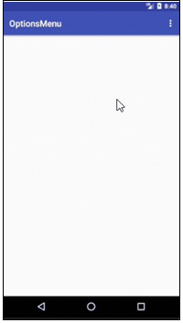

This is how we can create **Options Menu** in android applications to handle global functionalities in our application.

**Complete Code and Output**

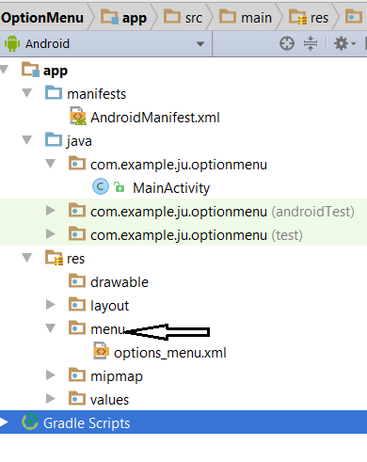

**File: AndroidMenifest.xml (as it is)**

**File: MainActivity.java**

**package** com.example.ju.optionmenu;  
  
**import** android.support.v7.app.AppCompatActivity;  
**import** android.os.Bundle;  
**import** android.view.Menu;  
**import** android.view.MenuItem;  
**import** android.widget.Toast;  
  
**public class** MainActivity **extends** AppCompatActivity {  
 @Override  
 **protected void** onCreate(Bundle savedInstanceState) {  
 **super**.onCreate(savedInstanceState);  
 setContentView(R.layout.***activity_main***);  
 }  
 @Override  
 **public boolean** onCreateOptionsMenu(Menu menu) {  
 getMenuInflater().inflate(R.menu.***options_menu***, menu);  
 **return true**;  
 }  
 @Override  
 **public boolean** onOptionsItemSelected(MenuItem item) {  
 Toast.*makeText*(**this**, **"Selected Item: "** +item.getTitle(), Toast.***LENGTH_SHORT***).show();  
 **switch** (item.getItemId()) {  
 **case** R.id.***search_item***:  
 **return true**;  
 **case** R.id.***upload_item***:  
 **return true**;  
 **case** R.id.copy_item:  
 **return true**;  
 **case** R.id.***print_item***:  
 **return true**;  
 **case** R.id.***share_item***:  
 **return true**;  
 **case** R.id.***bookmark_item***:  
 **return true**;  
 **default**:  
 **return super**.onOptionsItemSelected(item);  
 }  
 }  
}

**File: activity_main.xml**

*<?***xml version="1.0" encoding="utf-8"***?>*<**RelativeLayout xmlns:android="http://schemas.android.com/apk/res/android"  
 xmlns:tools="http://schemas.android.com/tools"  
 android:id="@+id/activity_main"  
 android:layout_width="match_parent"  
 android:layout_height="match_parent"  
 android:paddingBottom="@dimen/activity_vertical_margin"  
 android:paddingLeft="@dimen/activity_horizontal_margin"  
 android:paddingRight="@dimen/activity_horizontal_margin"  
 android:paddingTop="@dimen/activity_vertical_margin"  
 tools:context="com.example.ju.optionmenu.MainActivity"**>  
  
 <**TextView  
 android:layout_width="wrap_content"  
 android:layout_height="wrap_content"** />  
</**RelativeLayout**>

**File: options_menu.xml**

*<?***xml version="1.0" encoding="utf-8"***?>*<**menu xmlns:android="http://schemas.android.com/apk/res/android"** >  
 <**item android:id="@+id/search_item"  
 android:title="Search"** />  
 <**item android:id="@+id/upload_item"  
 android:title="Upload"** />  
 <**item android:id="@+id/copy_item"  
 android:title="Copy"** />  
 <**item android:id="@+id/print_item"  
 android:title="Print"** />  
 <**item android:id="@+id/share_item"  
 android:title="Share"** />  
 <**item android:id="@+id/bookmark_item"  
 android:title="BookMark"** />  
</**menu**>

**OUTPUT**

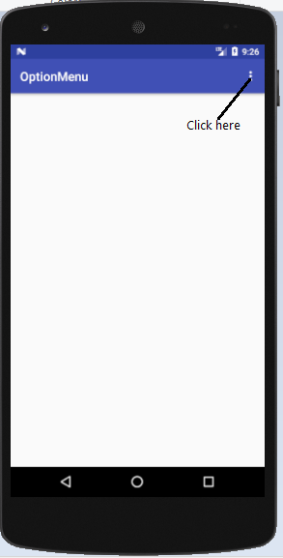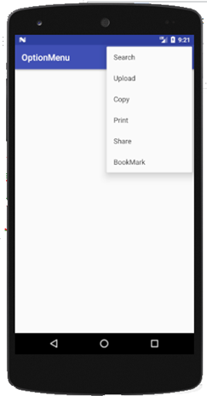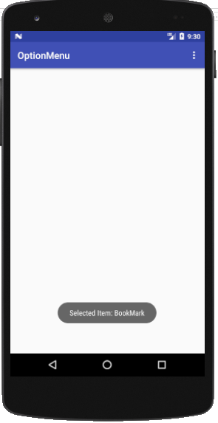

**Questions**

1. What are the different Options Menu Attributes in Android?
2. Which method is used to activate/override option menu (onCreateOptionsMenu()) ?
3. Which method is used to load menu resource (MenuInflater.inflate()) ?
4. Which method is used to handle item click event for option menu (onOptionsItemSelected() )?
5. Write the purpose of [using getMenuInflater() in android](https://stackoverflow.com/questions/52153806/what-is-the-purpose-of-using-getmenuinflater-in-general-in-android-stiudio).